

**USED CAR PREDICTION PROJECT**

**Submitted by:**

**IMRAN AHMAD**

**ACKNOWLEDGMENT**

This includes mentioning of all the references, research papers, data sources, professionals and other resources that helped you and guided you in completion of the project.

* I would like to thank FlipRobo Technologies for providing me this opportunity and guidance throughout the project and all the steps that are implemented.
* I have primarily referred to various articles scattered across various websites for the purpose of getting an idea on “*Used Cars Price*” project.
* I would like to thank the technical support team also for helping me out and reaching out to me on clearing all my doubts as early as possible.
* I would like to thank my project SME ‘Mohd.Kashif’ for providing the flexibility in time and also for giving us guidance in creating the project.

I have referred to various articles in Towards Data Science and Kaggle.

**INTRODUCTION**

**BUSINESS PROBLEM FRAMING**

In this project,we have to make used car price valuation model using new machine learning models from new data. Because with the change in market due to covid 19 impact, our client is facing problems with their previous car price valuation machine learning models.

**CONCEPTUAL BACKGROUND OF THE DOMAIN PROBLEM**

1.Firstly,we will prepare our own dataset using web scraping.

1. After that we will check whether the project is a regression type or a classification type.
2. We will also check whether our dataset is balanced or imbalanced. If it is an imbalanced one, we will apply sampling techniques to balance the dataset.
3. Then we will do model building and check its accuracy.
4. Our main motto is to build a model with good accuracy and for that we will also go for hyperparameter tuning.

**REVIEW OF LITERATURE**

With the covid 19 impact in the market, we have seen lot of changes in the car market. Now some cars are in demand hence making them costly and some are not in demand hence cheaper.

**LIBRARY**

* In this project we use different liabrary like pandas,numpy,seaborn and sklearn to complete our task.

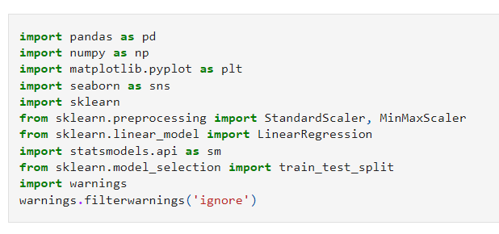

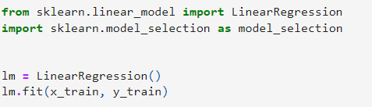

**EDA**

* In EDA we found that the newest car have more value than the oldest car which was manufacture after 2017.

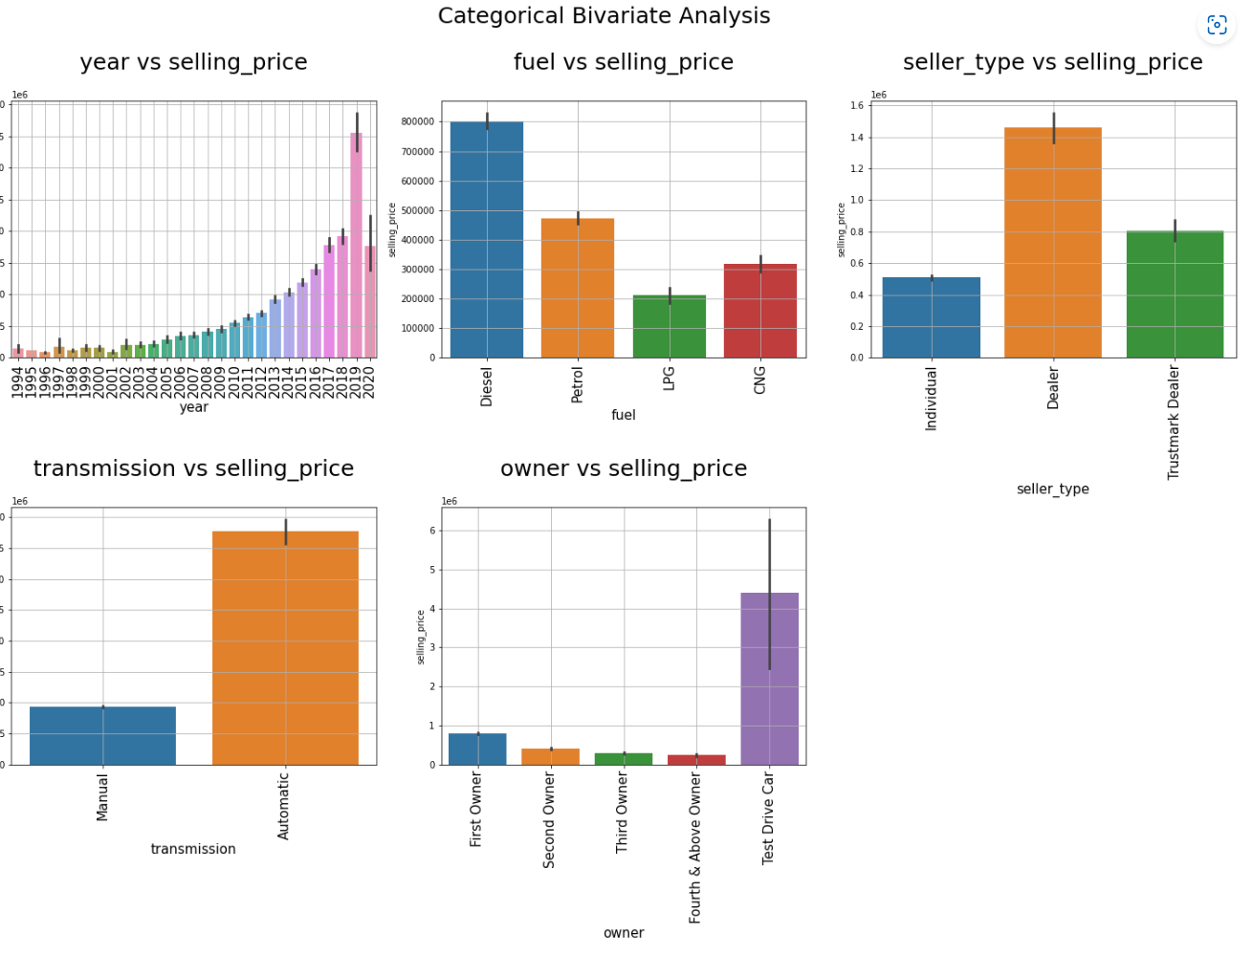

**Model Building**

* In model building we firstly used tarin test split and after that put linear regression algorithm.
* 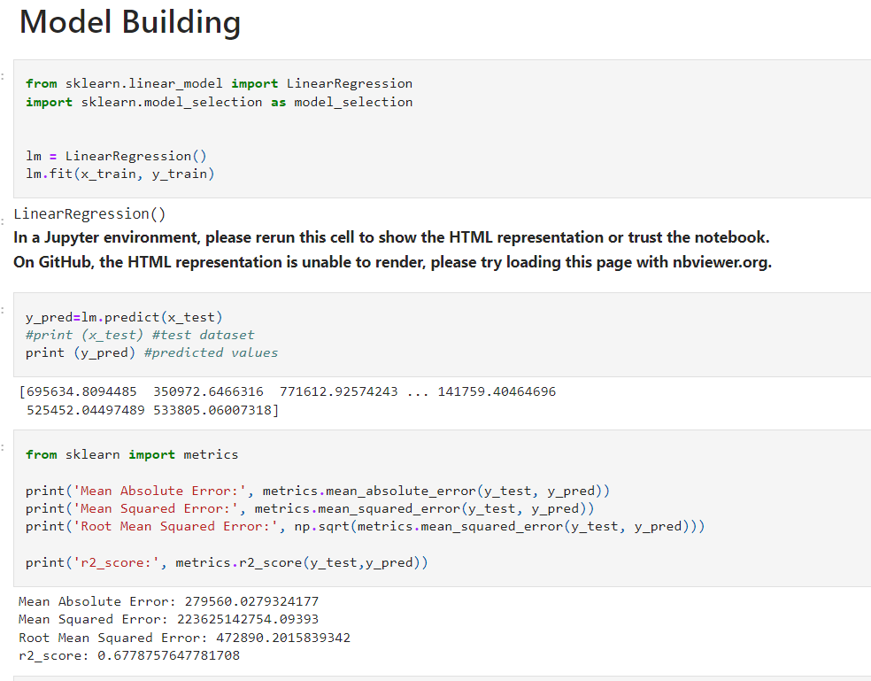

**CONCLUSION**

Key Findings and Conclusions of the Study:

· The purpose of this article was twofold: to understand the pattern of used cars market and make predictive model, which is able to effectively predict the price of used cars.

· We use many algorithms to find best model and best result were observed of the random forest regressor with 78% r2 score accuracy with good mean absolute error.

· There are many variables important to predict the price of houses. Like driven kilometres, car model, fuel of car etc.

· By using machine learning model our client can decide whether to increase or decrease the price of used cars.

Limitations of this work and Scope for Future Work:

· In future we may add large historical data of car price which can help to improve accuracy of the machine learning model.

· For better performance, we plan to judiciously design deep learning network structures, use adaptive learning rates and train on clusters of data rather than the whole dataset